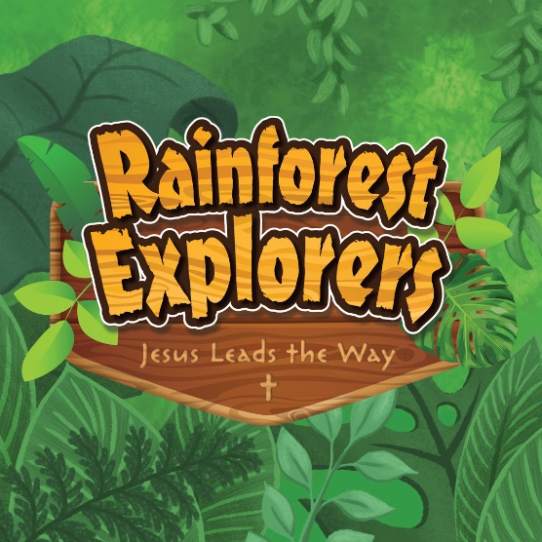
Songs,
Crafts &
Fun

Activities,
Stories &
Snacks

Saints Peter and Paul
Vacation Bible School Rainforest Explorers
Jesus Leads the Way!
Monday, June 13th - Thursday, June 16th 9 AM – 12 PM
$45 per child
Ages 4 (must be potty trained) through 5th grade
Register deadline is Wednesday, May 25th Please email, mail or drop off the form and payment to
Saints Peter and Paul Parish Office or send through school or PREP.
Parent name:
Parent email:
Cell/best phone number to reach you:
Emergency Contact person (name and phone number)
Child’s name and age:
Additional children and their age:
I have my clearances and can help on the following days:
My child in grade 7 or up can help on the following days:
Amount Paid:
We will serve a snack coordinated with the day’s lesson. Please let us know of any allergies or any other information that we should be made aware of.

He took the children in his arms, placed his hands on them and blessed them ~ Mark 10:16

